ONLINE PIZZA ORDERING SYSTEM

Revision History
Version No. | Date | Prepared by / Modified by | Significant Changes
 |  | Sanidhya Sakhuja
 |  | Abhishek Tiwari
 |  | Harsh Kori
 |  | Kalpesh Jadhav
 |  | Mohd. Sakib Hussain

Glossary
Abbreviation | Description
BSC | Business Story Card
TSC | Technical Story Card
OPOS | Online Pizza Ordering System
JAVA EE | Java Enterprise Edition 5
HTTP | Hyper Text Transfer Protocol
HTTPS | Secure Hypertext Transfer Protocol
TCP/IP | Transmission Control/Internet Protocol

Table of Contents
1 Introduction
1.1 Why is an Online system for Pizza ordering needed?......................................................

1.2 Objectives of Online Pizza ordering system…………………………………………….

1.3 How does this system work?............................................................................................

2 Technologies to be used…………………………………………………………………..
3 Project Feasibility
3.1 Economic Feasibility…………………………………………………………………….

3.2 Technical Feasibility……………………………………………………………………...

3.3 Operational Feasibility……………………………………………………………………
4 Requirement Specification
4.1 Functional Requirement
4.1.1 Ordering
4.1.2 Ordering Process
4.1.3 Administration
4.2 Non Functional Requirement
4.2.1 Performance Requirements
4.2.2 Safety Requirement
4.2.3 System Security Requirements…………………………………………………………

4.2.4 Software Quality Attributes…………………………………………………………..
5 System Design Specification
5.1 User Case Diagram………………………………………………………………………

5.2 ER Diagram…………………………………………………………………………..

5.3 Data Flow Diagram………………………………………………………………………

Introduction

Why is an Online system for Pizza ordering needed?
You must have ordered your pizzas by phone for home delivery. The process seems easy to use but at times there is miscommunication. As there is no visual menu shown during a phone call, the employees have to repeat a lot of things again and again to the customers. It’s a time-consuming process that at times irritates customers. Also, it takes a lot of time for the pizzeria staff. It would be much more comfortable for the customers to have an online pizza ordering system. It would be hassle-free for users as they can select the pizzas they want and make payment for it. Also, it will reduce the purchasing time for customers. Let us look at another benefit of using this system. Suppose I go to a pizzeria and make the order. Even after ordering pizzas from their outlet, I have to wait at least 15 minutes for my order to be ready. Wouldn’t it be much more convenient if I ordered my pizzas before using a mobile app or an online system and then it will tell me the time by which I have to pick my order from their counter? It would be great for me as I don’t need to wait for my pizza. I need to reach there only when my pizza is ready. In a nutshell, we can say that improved and efficient services are provided to the customers by the inclusion of internet in your business. From a business point of view, it gives you an edge over your competitors.

Objectives of Online Pizza Ordering System:
The main objectives of this ordering system are

Build your own pizza – This system will help customers in ordering custom pizzas. So, the customer will pick exactly the things which he/she wants in their pizza. This will surely enhance the image of the pizzeria and customer satisfaction will be greater.

Online Payment– This system will give the option to the customer for online payment. This will make the pizza buying experience cash-free.

Better Knowledge– This system will provide the customer with all the details of his order before making the order. This confirmation will help customers to check the items ordered with their prices.

Know Delivery Time– This system will show the time by which the order will be delivered to the customer. For pick-ups, customers can fix the time by which they will pick their order.

Reduce Paper Work– As most of the things will be performed online, it will reduce the usage of paper for the pizzeria.

Improves Efficiency–
• This system will make things easier for staff as the whole ordering process is done by the customer only.
• These were the objectives of the online pizza ordering system.

How does this system work?
Let us now understand the working of this system. Whenever a customer visits the webpage or mobile application of the pizzeria, he/she will have to select his location so that the order is made to the nearest pizzeria. The menu will be visible to the customer with the pizzas and other non-pizza products on offer. All the ingredients will be shown at their prices. Now the customer will customize his pizza and make changes to the ingredients if he wishes and select the quantity for it. After selecting the items to be ordered, the customer has to select the type of order whether it will be home delivery or pick up. After that, the customer has to provide his/her details like name, phone number, address, email id. Now the payment option is shown to the customer. He has to choose from the various online payment methods or cash-on-delivery options. After this process, the order is made and the customer is notified about the time by which the pizza will be delivered to them.

Technologies to be used
The system will be created by using the following tools:
1. Java Enterprise Edition (Java EE)
2. Frontend tools: HTML, CSS & JavaScript
3. Frontend Framework: Angular JS
4. Backend tools: Spring Boot
5. Database: Oracle

Project Feasibility
The feasibility of a system means ensuring that the system which we are going to implement is efficient and affordable. There are various types of feasibility to be determined. They are:

Economic Feasibility
Development of this application is highly economically feasible. The only thing to be done is to make an environment with effective supervision. It is cost effective in the sense that it has eliminated the paperwork completely. The system is also time effective i.e., saves a lot of time for both customers and pizzeria staff.

Technical Feasibility
The technical feasibility for the system is economic and does not require expensive Hardwares. Technical evaluation must also assess whether the existing system can be upgraded to use the new technology and whether the organization has the experience to use it. Install all upgrades framework into the package supported windows/android/iOS-based system.

Operational Feasibility
The system is quite easy to use and learn due to its simple but attractive interface. Users require no special training for operating the system. Technical performance includes issues determining whether the system can provide the right information for the client and admin and whether the system can be organized so that it always delivers this information at right place and on time using intranet services.

Requirement Specification
<Provide details of the Design/approach for developing/implementing the requirements>

Functional Requirements
Modules of online pizza ordering system:
There are 3 modules in this system. These modules are:
• Ordering (User Interface)
• Order Processing (Pizzeria Interface)
• Administration

4.1.1 Ordering

This module will provide an interface for customers to order their pizzas
Login/Sign-Up:
When a customer visits the online pizza ordering system of any pizzeria, he will be asked to log in or sign up for them for a better experience. The customer has to create a unique username and a password. Then he /she needs to enter details like Name, phone number, address. After these steps an account of that customer will be created.

Menu:
• The system will provide customers with a menu in which all the pizzas and non-pizza items will be shown along with their prices. The pizzas on the menu are created by the professional chefs of the pizzeria.
• The ingredients in this pizza can be changed according to the customer’s interests. The customer can select any pizza from the menu or build a custom pizza.
• Each pizza will be shown with its image and price. The ingredients used in the making of that pizza can also be seen.
• Each of these ingredients can be removed or other new ingredients can be added in the order.
• After each selection or de-selection, the grand total of the order will be updated.

Build Your Pizza:
One of the most amazing features of an online pizza ordering system is that you can build your pizzas from scratch. This system provides the options to create your custom pizzas with everything of your choice. Let me tell you more about making custom pizzas.
• The customer will get an option to select the pizza’s crust size which can be small, medium, or large.
• Then the customer has to choose the sauce to be used on his pizza crust. These can marinara, cheese, ranch, and others.
• Then the system asks the customer whether to add cheese or not. He also has an option to select extra cheese.
• Finally, the system shows the customers different types of toppings. Firstly, the customer has to choose between veg. and non-veg. toppings. Suppose you selected veg., then different options like pineapple, mushrooms, olives, etc. are shown.
One important point to be noticed here is after each step, the updated price of your custom-built pizza is shown to the customers. Each item’s price is also reflected below its image.

Add To Cart:
This feature is useful in a situation where you have to order more than one pizza or other non-pizza items. Suppose you have selected a Margherita pizza and now you want to select another pizza as well. Then you just have to add that pizza to the cart using the Add to cart option. Items added to the cart will be saved so that you can choose other pizzas as well. Finally, when you are ready to order you can check out from the cart to make payment.

Payment:
There will be basically 2 payment options i.e., online payment using Credit/Debit cards and Internet banking or Cash on delivery. Before making payment, your order details are shown and confirmed. This system makes transactions easier as the need to pay with cash is not there.

Home Delivery or Pick up:
This feature asks the customer if he/she intends to pick up his/her order from the pizzeria or if it needs to be delivered to their address.

Track your Order:
This is another interesting feature which helps customers to keep track of their orders. The customer is notified at every step of their order completion. After making payment the customer is shown the time by which his order will be delivered to his doorstep.

Feedback:
Feedback is further used to develop and improve services provided by the pizzeria. This Module can be reached After the customer has ordered, visible beside the billing details.

Order Processing
How the pizzeria manages the order made by the customer and delivers it on time. The online pizza ordering system comes to their rescue again. It provides all the features and functionalities for processing orders without any fuss for the staff of the pizzeria. This module will be used by the employees of the pizzeria for preparing orders and delivering them to their destination. Each employee of the pizzeria will have an account in this ordering system. They will have a username and password provided to them by the system admin. Mainly there are three types of employees using the online pizza ordering system. They are Kitchen staff, delivery staff, and other employees like the counter staff.

Kitchen Staff:
They have an interface that shows them the list of orders to be prepared. Each order shows its details like ingredients to be used and the quantity of each item. The current status of each order is pending. After a particular order is prepared and ready to be delivered, the kitchen staff updates the status to ‘Prepared’. The customer is notified at this stage that their order is prepared and will soon be delivered.

Delivery Staff:
After the order is prepared the available delivery staff is handed over the orders with their address. When the delivery staff leaves for delivery the status of the order is updated again to ‘Out for Delivery’ and the customer is notified. When the delivery staff delivers the order successfully, he updates the order status to ’Delivered’. If he fails to deliver the order due to any reason, the status is updated to ‘Delivery Failure’.

Counter Staff:
In case of pick up, the counter staff updates the status of the orders. When the kitchen staff has prepared the order, the counter staff updates the status to ‘Ready to be picked’ and the customer is notified that he can pick up his order now. After the customer picks up his order, the counter staff updates the order status to ‘Received by customer’. Each kind of employee has their own rights and permissions. The kitchen staff has a right to only check pending orders and update status to ‘Prepared’. He cannot update the order status to ‘Delivered’ as he doesn’t have the right to do so.

Administration:
The administration module is equally important in the functioning of this system. The user of this module is known as Admin or superuser. He is the master of this online system. Admin has all the rights and power to use this system.

The tasks which can be performed by the admin are:
1. He can add/edit/delete different ingredients into the system. He can add/edit/delete new pizzas, their images, prices, and other details. The same functions can be performed for non-pizza items. 2. He can add/edit/delete users in this system. It’s the admin who adds new employees’ accounts to the system.
3. Admin has the right to add/edit/delete orders for customers.

Non-Functional Requirements
The Non-Functional Requirements have been divided into the following modules:

Performance Requirements

1. The system shall accommodate a high number of items and users without any fault.

2. Responses to view information shall take no longer than 5 seconds to appear on the screen.

3. The system shall provide appropriate messages to the user as the user submits any input.

Safety Requirements

System use shall not cause any harm to human users –both physically and mentally.

System Security Requirements

1. Access to the system and information must be controlled.

2. Privacy should be maintained, i.e., passwords should be viewed in encrypted form.

3. System should store data in secured servers and must have backup of the server data.

Software Quality Attributes

If the connection between the user and the system is broken, the system should enable the user to recover an incomplete request from the beginning.

System Design Specifications
5.1 User Case Diagram

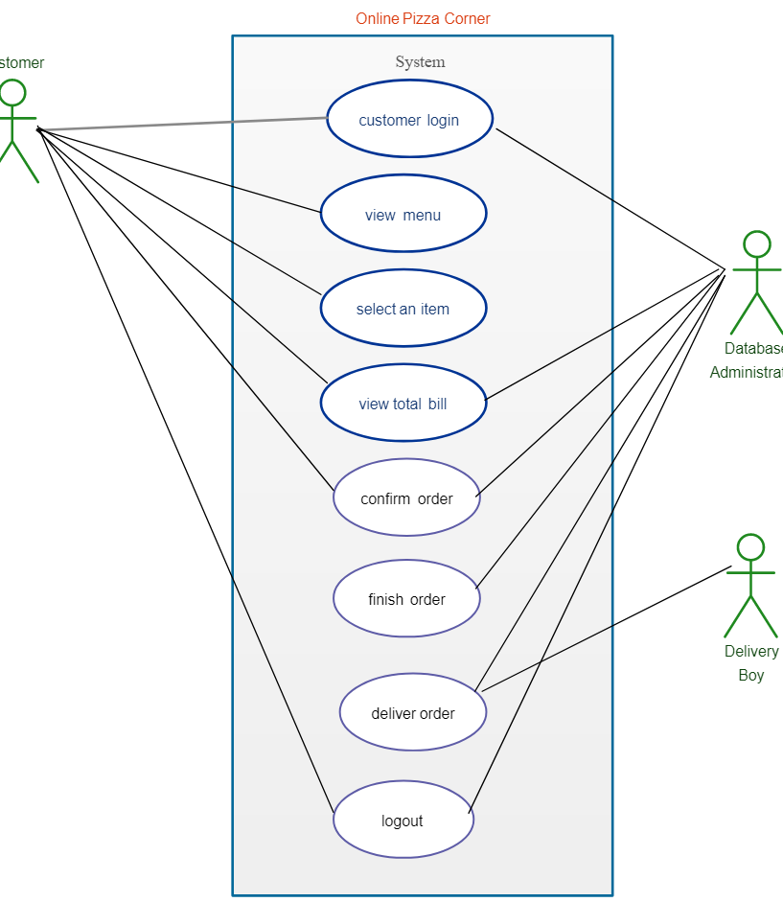

5.2 ER Diagram

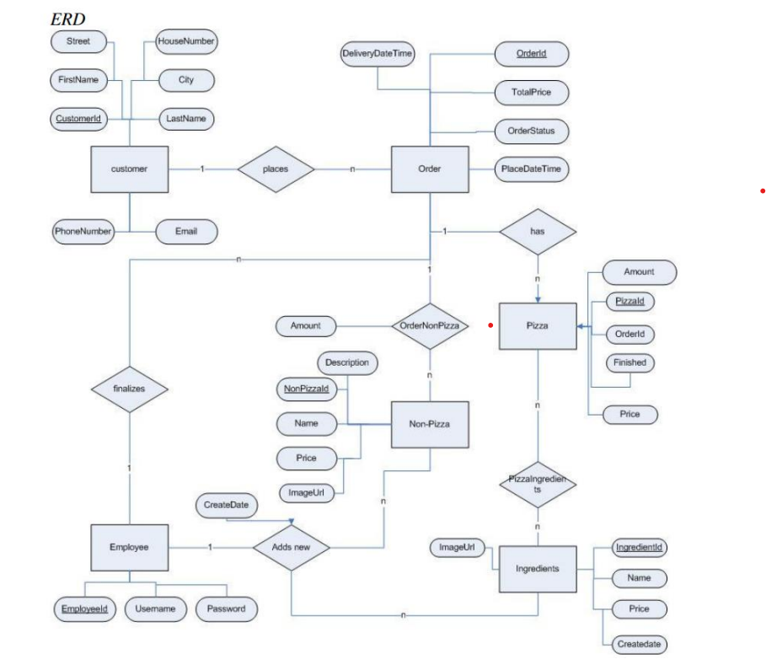

5.3 Data Flow Diagram
